**Statement of Work (NO. 2)**

This STATEMENT OF WORK NO. 2 (“Statement of Work” or “SOW”) is made as of February 3, 2021 (“Effective Date”) between Terumo BCT Europe N.V., having its registered address at Ikaroslaan 41, 1930 Zaventem, Belgium (“Terumo BCT”) and Alton Russell having its registered address at 1200 Rue Crescent APP 704, Montreal, Quebec, Canada H3G 2A9 (“Service Provider”).

This SOW is made under and governed by Master Services Agreement as of October 9, 2019 between Terumo BCT and Service Provider.

Under this SOW, Service Provider shall perform the Services for Terumo BCT as described below.

|  |  |  |  |
| --- | --- | --- | --- |
| Workstream | Fee | Delivery date | Note |
| * Additional analysis to estimate the effectiveness of whole blood PI in terms of disability-adjusted life years averted instead of just adverse event cases averted. This will also allow us to conduct a cost-utility analysis, reporting the ratio of cost per DALY. | 500 Euros | March 15th, 2021 |  |
| * Incorporation estimates of the utility weights and mortality for each adverse event into the analysis and report additional outcomes. | 500 Euros | March 15th, 2021 |  |

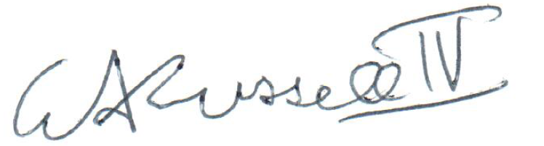

Signed 2021-02-22 by W. Alton Russell